**Using FIP Log as a Warrior Admin**

Description: The FIPLog.com website can be used by admins to help track and monitor the kittens. This can help admins better guide treatment decisions, and allow for blood work and other files to be stored and associated with specific cats and parents.

**Tracking Other Cats: Getting Started**

To start tracking kittens, you need an account on the FIP Log website.

*Account Creation*

1. Go to <https://fiplog.com>
2. Click “New Account” if you do not already have one, or “Login” if you do.

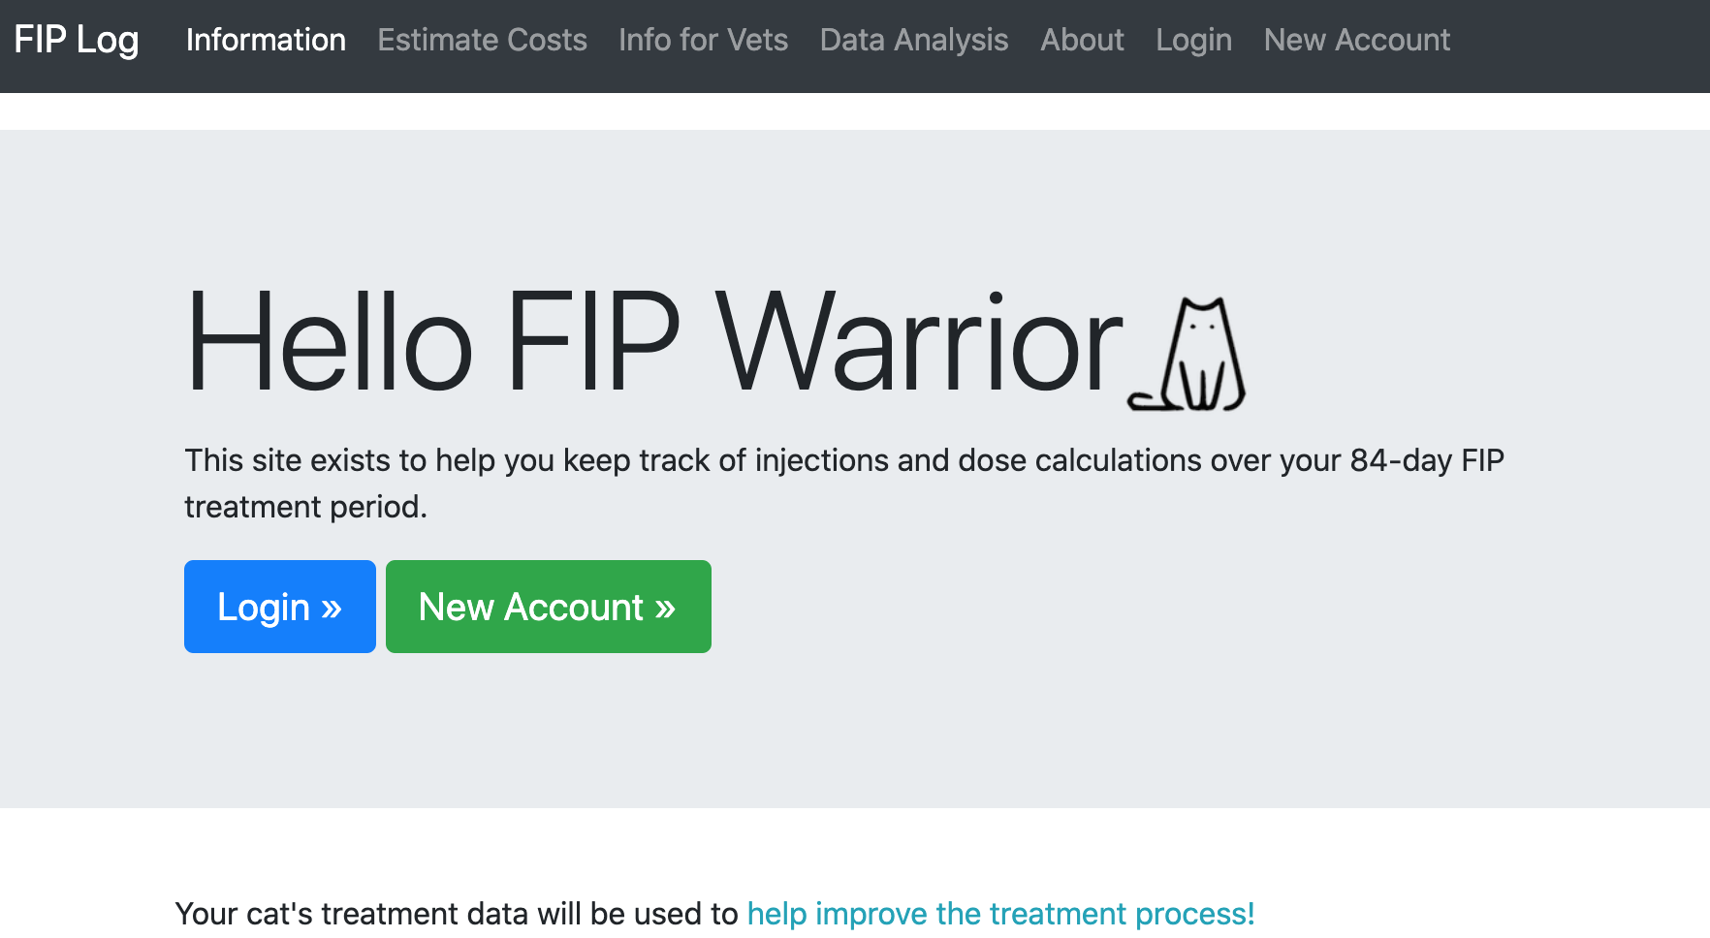

1. Create an account or Login.
   1. Please **make a memorable username** – there is not currently functionality to recover usernames if they have been forgotten.
   2. Please **use a valid email address**, as this will allow for better error tracking, and to keep you informed of potential updates in the future.

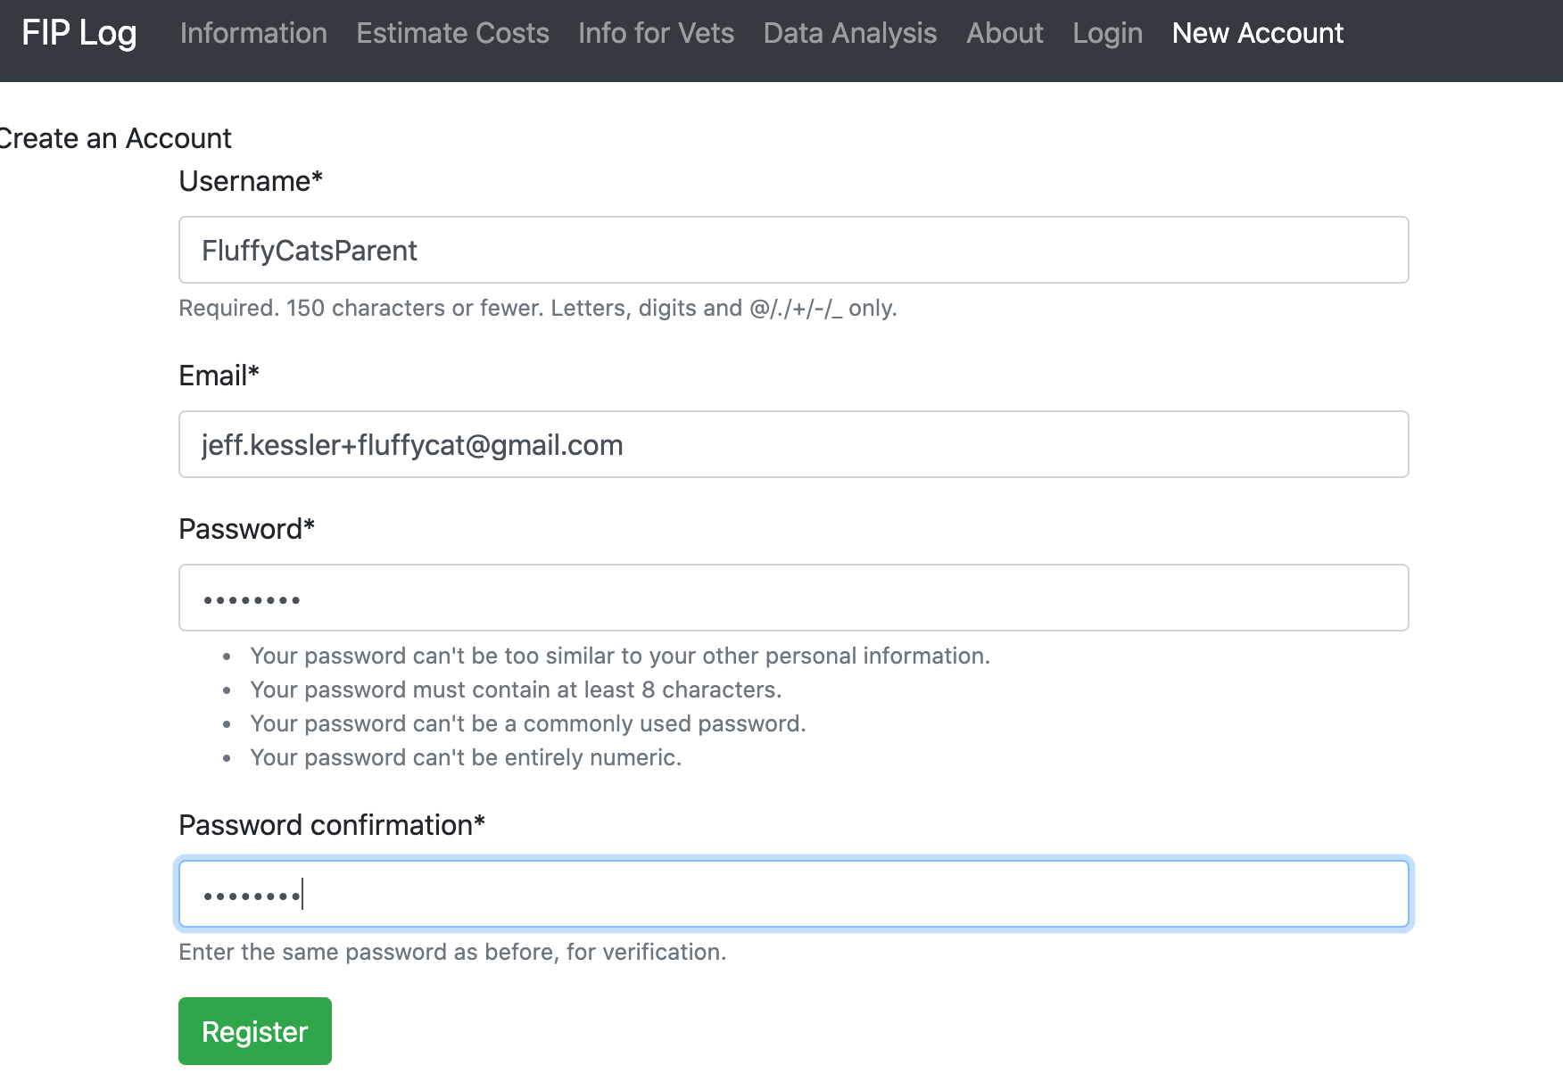

Tracking Kittens

1. Once logged in, you will now be taken to the main site. As you are not likely treating your own cat, the site will look like this:

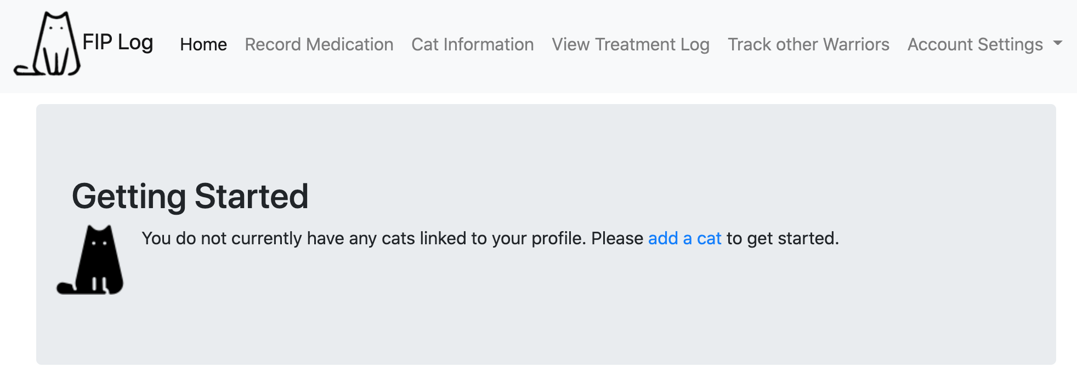

1. Click on the “Track other Warriors” menu item to start tracking and viewing other warriors.



1. To track a cat, you need to have the warrior’s 36-digit share link. The parent will be able to retrieve this link from their “Cat Info” page. See discussion below on how to do that.
2. Enter a cat’s share link (that the parent gives you), and an identifier that will help you know which parent/cat it is. An example is shown below.

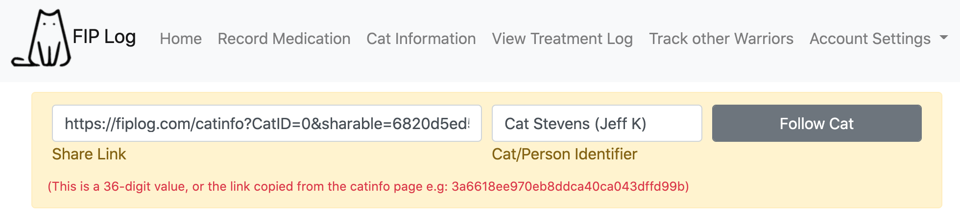

A value that you enter so you know what cat/parent it is. This can be anything you want it to be

The share link the cat’s parents will send you

1. Click submit, and a cat’s info will now appear on your “Track other Warriors” page.

*Note: As long as you’re logged into the website, you can directly use a parent’s share link to access their cat’s info, or you can add that share link to your account.*



**Getting a Share Link from Parents**

1. When parents log into the website, they will typically see a page that looks like this:



1. They should go to the “Cat Information” page, and select the cat they want to share from the drop-down menu



1. This will take them to the cat information page, which has a button to “Copy” their cat’s share link



1. Clicking the Copy link button will change the button to green, and will add the link to their computer (or smartphone’s) clipboard. They can now paste it into a chat window/SMS/email etc.

